Christophe Thill & Yona Jervis
BCLC1 LGK
WSUS Documentation

Contents
Scenario 2
Documentation 3
Installing Windows Server Update Services 3
The WSUS Wizard – Initial Configuration 7
Configuring WSUS computer groups 12
Configuring the GPO 12

Scenario
We are the System administrator for a school. This school has around 200 PCs, which need some updates from time to time.

So that we don’t need to manually update every PC we use the service from Windows called “Windows Server Update Service”. This service lets us download and deploy updates to the PC from the intranet.

We have decided that we have one server that runs the WSUS in addition we have one HDD that stores or will stores future updates.
For the infrastructure we have decided to split the PCs into groups. The first group it for testing the new Updates. The second group is for all PC that students can use, and the final group is for the staff of the school. We want to test the update before deploying them, so we create a group that only has our test PC in it. After testing we can approve the update for every other PC in the building.

Documentation
Search for Server Manger in the windows search bar and open “Server Manager”.
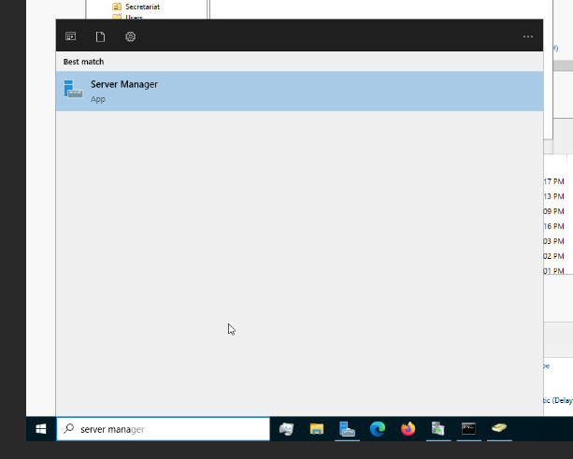

Installing Windows Server Update Services
Under “Manage” at the top right, start the role and features wizard.
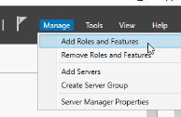
Click on [Next >]
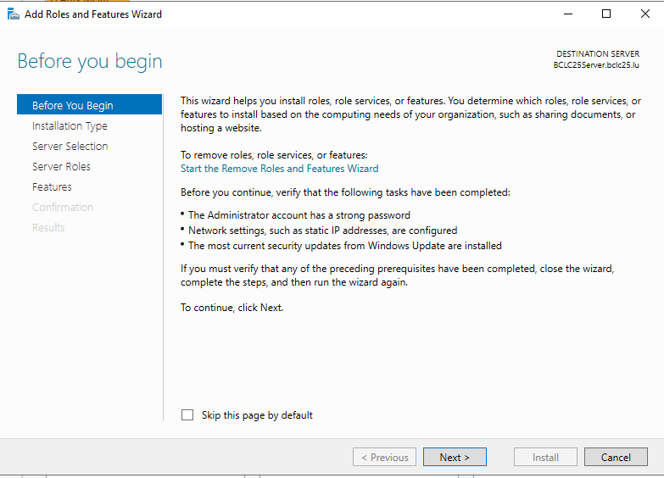
Select a “Role-based or feature-based installation”.
Click on [Next >]
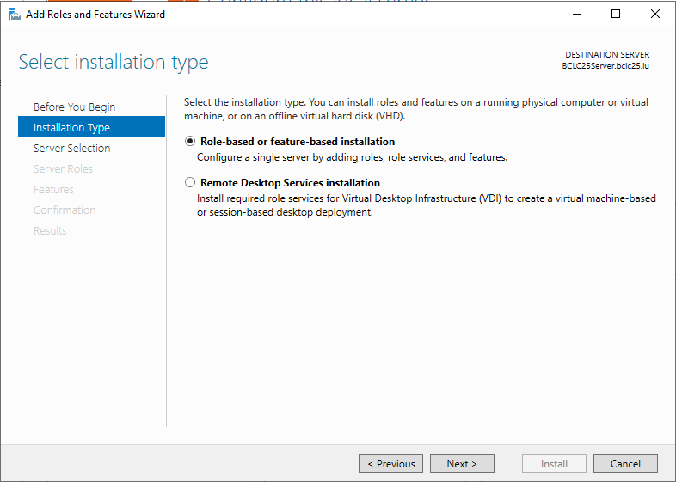
Select the destination server. In our case it is the local one.
Click on [Next >]
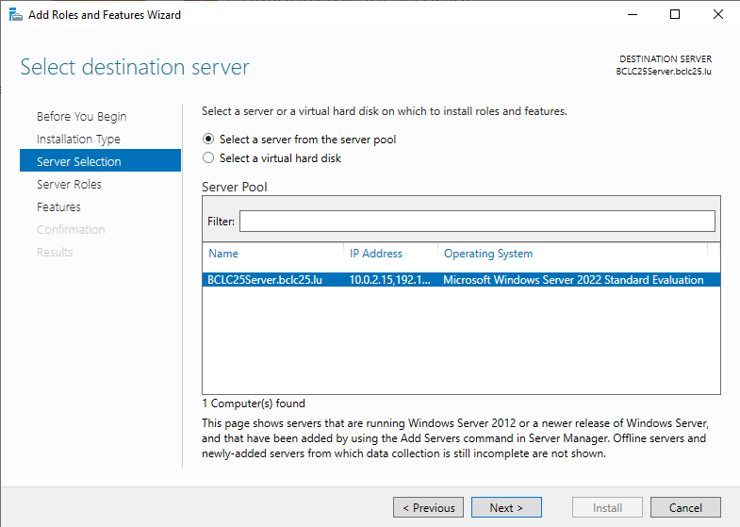
On the “Select server roles” page, check “Windows Server Update Services”. This is the role we are interested in.
Click on [Next >]
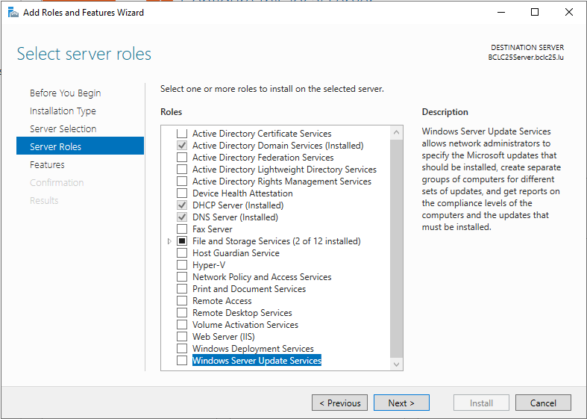

Windows Server Update Services has dependencies that have to be met. It will also install IIS Web Services which could also cause conflicts with other web servers. Make sure the “Include management tools” checkbox is checked and click on “Add Features”.
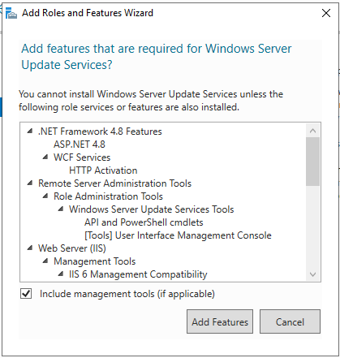

As all the dependencies are already met, just click on [Next >] on the “Select Features” page.
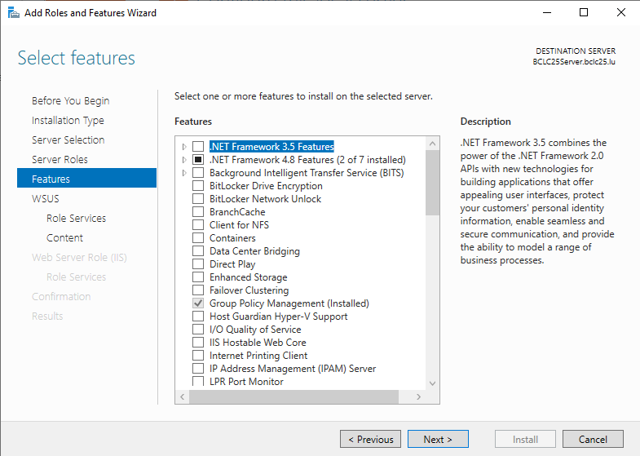
The “Windows Server Update Services” page will give some information about the service.
Click on [Next >]
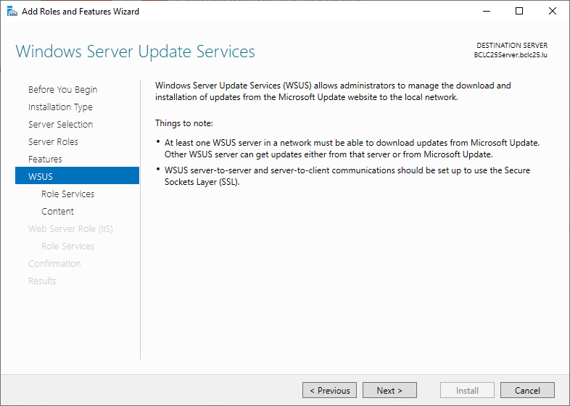
WSUS needs a database. You can either use the WID database or SQL. In this case we will choose WID. Also check the “WSUS Services” checkbox.
Click on [Next >]
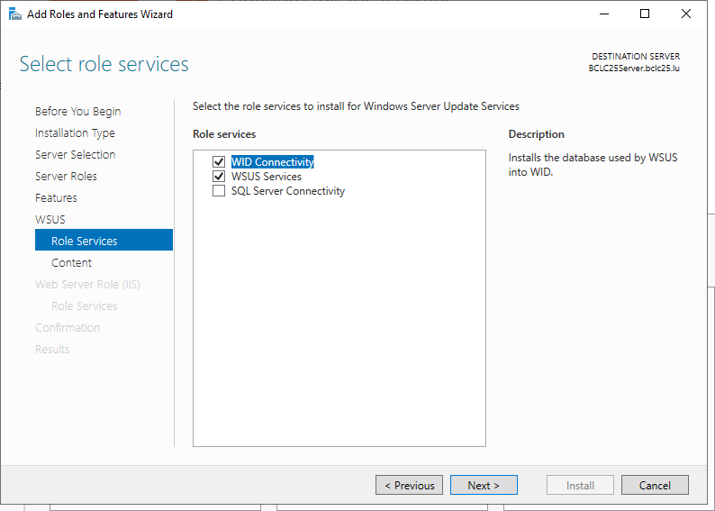

Now you need to create a folder so that WSUS can store the updates. It is recommended to put the updates onto a different disk. Check the “Store updates in the following location” checkbox, and put in the Local Path (E:\WSUS for example), or a remote server path.
Click on [Next >]
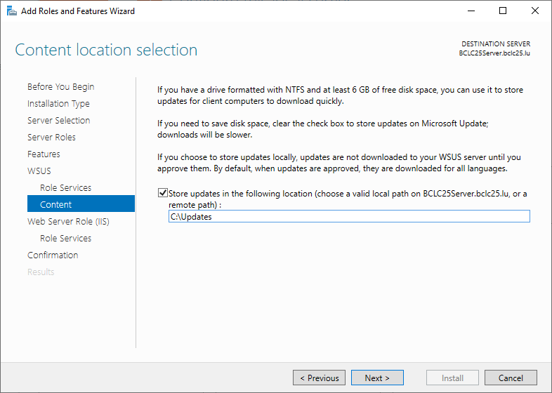
As we also need the IIS Web Server, it will display information.
Click on [Next >]
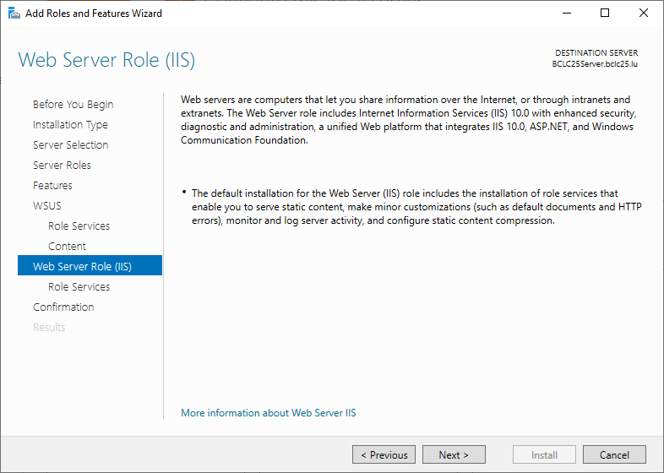

Under the IIS “Role Services” keep the defaults unless you need a specific feature later.
Click on [Next >]
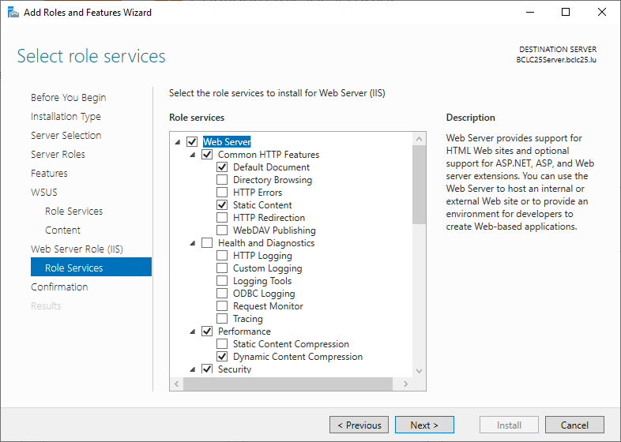
On the “Confirm installation selections”, confirm that the correct services have been selected. Click on [Install]. This will now take some time. After it has been installed, restart the server.
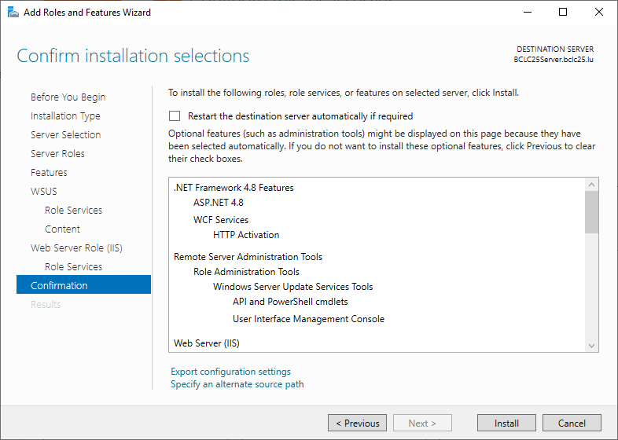

The WSUS Wizard – Initial Configuration
Start the WSUS Wizard. You can find it under “Tools” in the top right corner.
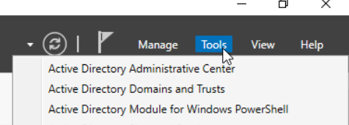

It will ask for prerequisites. Make sure the firewall allows necessary connections, or else WSUS will not work.
Click on [Next >]
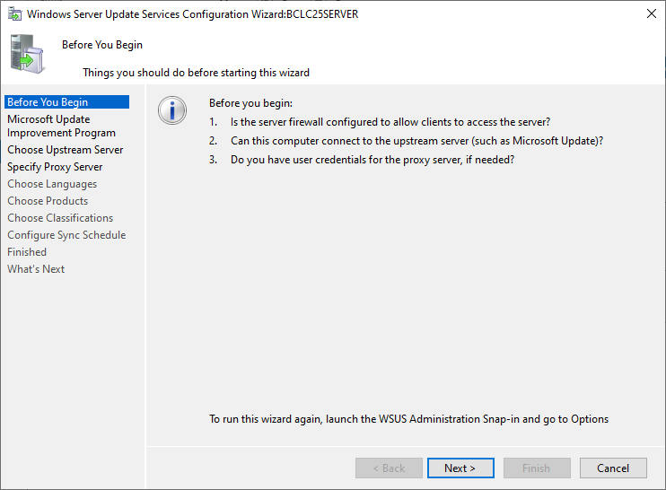
Microsoft wants to collect data on WSUS installs. Check it or not, that’s your choice.
Click on [Next >]
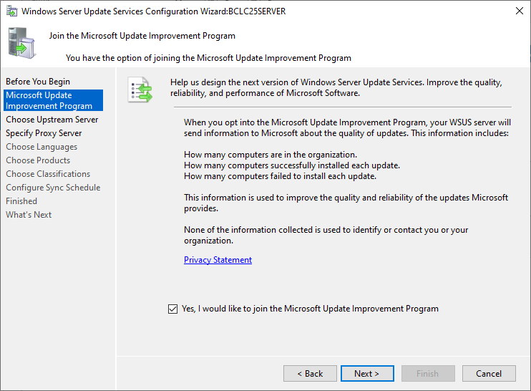
As this is our first WSUS server, we will need to synchronize it with Microsoft to get the updates. Once we have a WSUS server running, we can pull the updates from that server. Therefore check the “Synchronize from Microsoft Update” checkbox.
Click on [Next >]
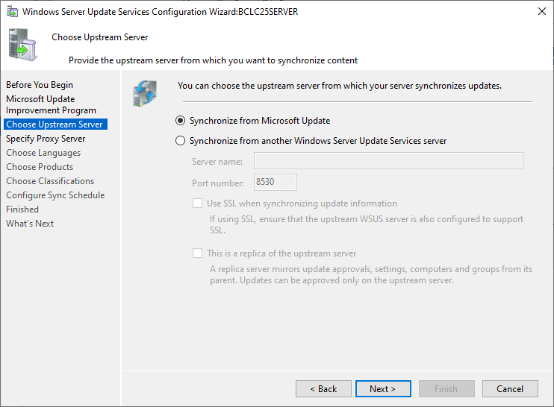
In our case, we don’t need a proxy. If you do, enter your details on the “Specify Proxy Server” page.
Click on [Next >]
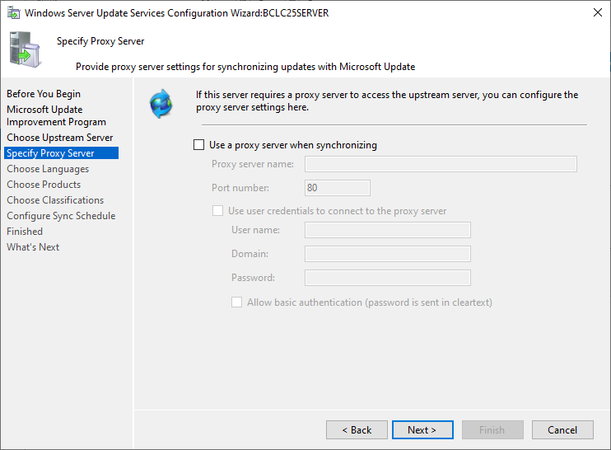

Now we can start synchronizing the list of available updates onto our server.
Click on [Start Connection]
This will take a while. Once it is finished:
Click on [Next >]
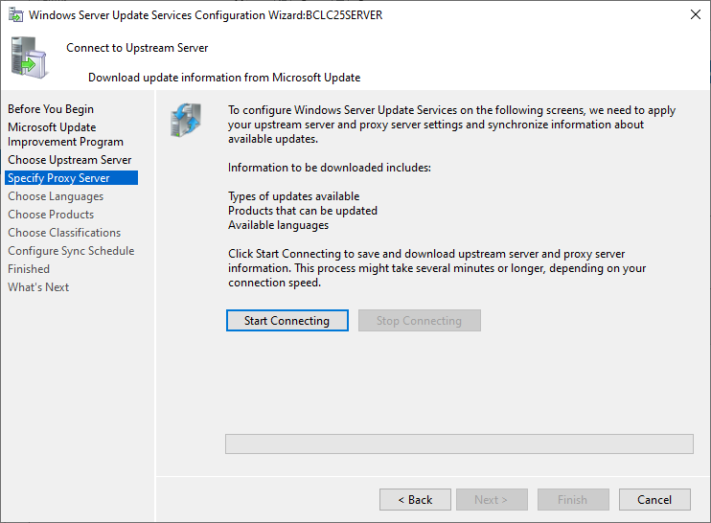
We just choose the English language pack, because we just want to store and to distribute English versions of windows. This will also save on space.
Click on [Next >]
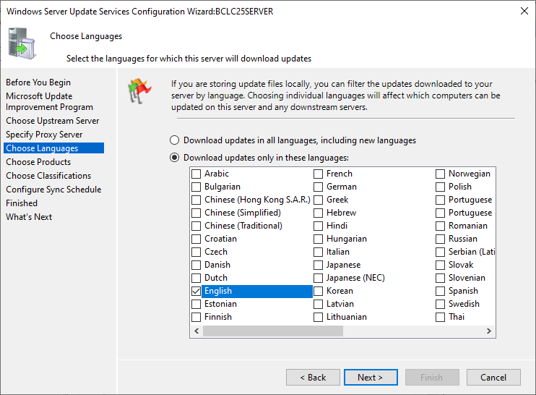

We can now choose which Microsoft products we want to download updates for. Examples would be Windows 10/11 and server versions. If you know that a product is being used more than once in the network, choose it.
Click on [Next >]
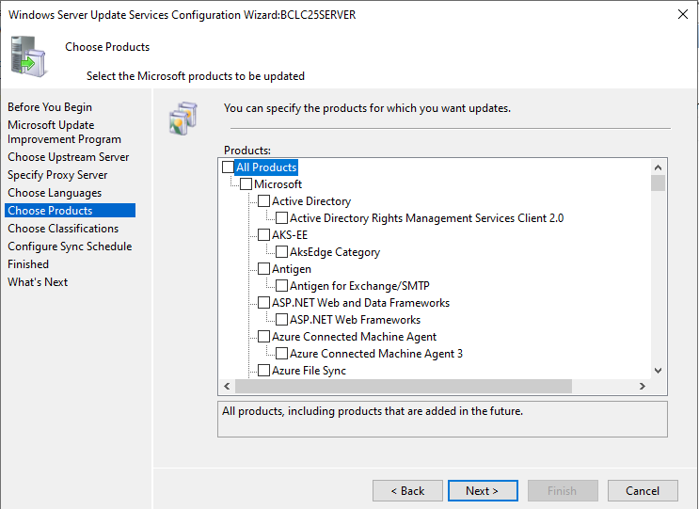
If you only want to download security updates, you can choose it in the classifications. We left it at the default.
Click on [Next >]
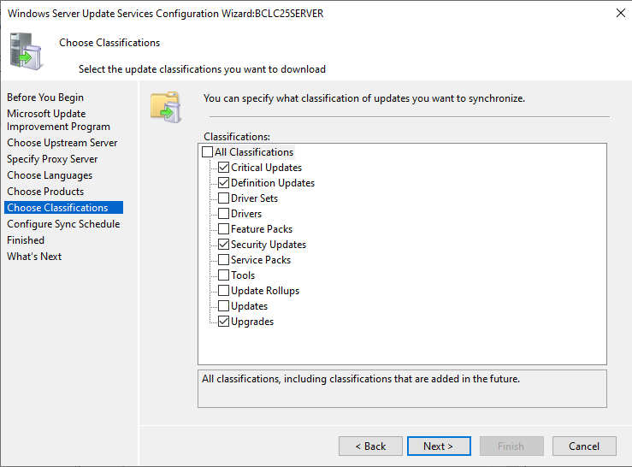

The wizard will now ask us when it should synchronize the updates. Either manually or automatically. We choose to synchronize automatically 1 time every day on midnight.
Click on [Next >]
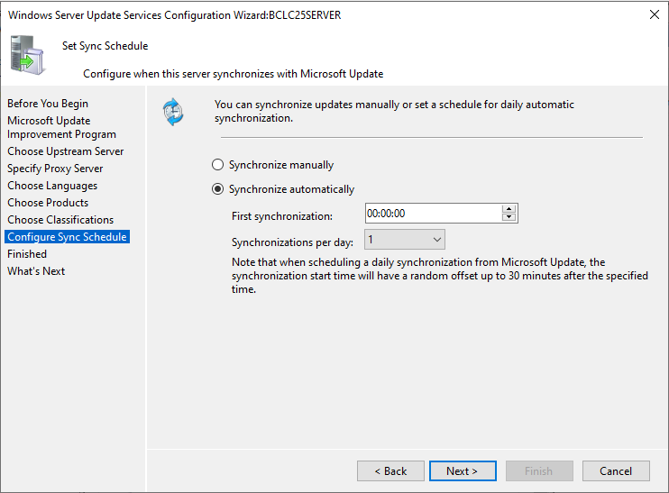
Now you configured WSUS. Select the “Begin initial synchronization” checkbox.
Click on [Next >]
This will take a long time, as it’s now downloading all the updates for all the selected products.
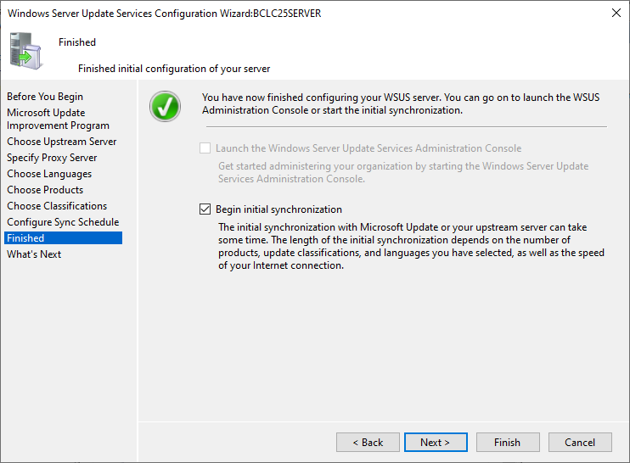

Configuring WSUS computer groups
We added our groups into the Updated Service, by right clicking the “All Computers” and selecting “Add Computer Group”.
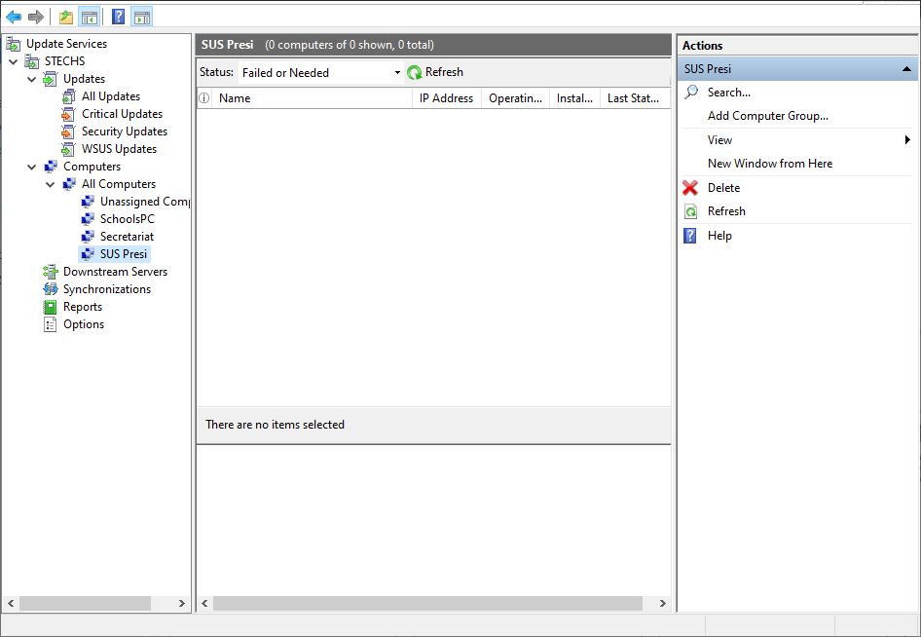

Configuring the GPO
Open the “Group Policy Managment”. Navigate to the “Group Policy Objects” (Forest -> Domains -> ”sometech.lu” -> Group Policy Objects). Create a new group policy by right clicking the “Group Policy Objects” folder. In this case we will call it “WSUS GPO”.
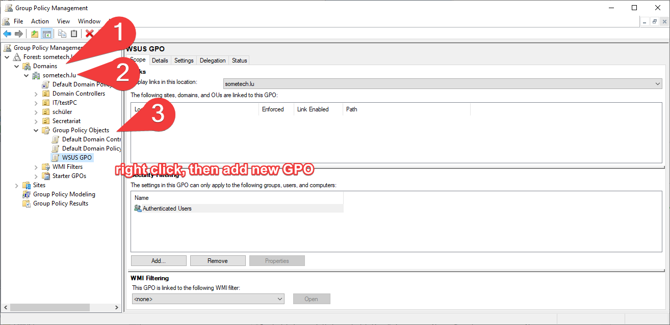

Right click the newly created WSUS GPO and edit it. Navigate to the following place (Computer Configuration -> Policies -> Administrative Templates: Policy definition-> Windows Components -> Windows Updates). Now find the “Specify intranet Microsoft update service location” and open it.
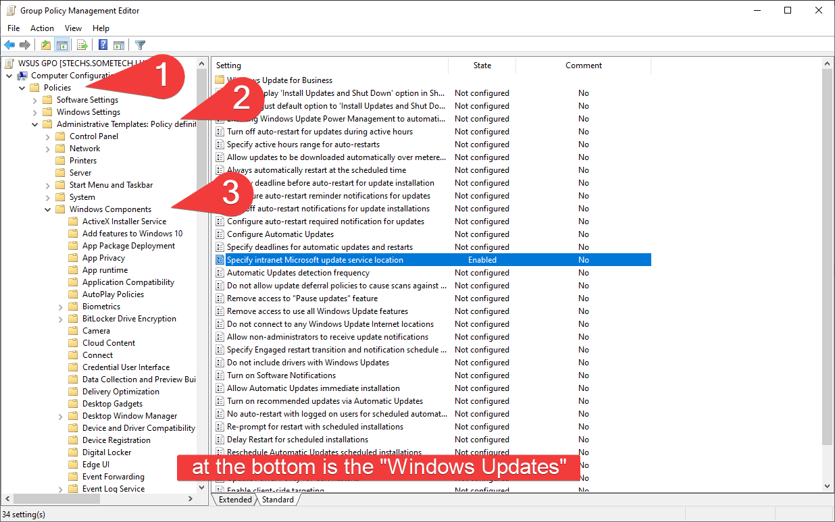

In this Policy we define where our WSUS server is located. First enable it at the top, then set the location to the WSUS server including the port. In this case it is “http://sometech.lu:8530”. After configuring the policy, click on [OK].
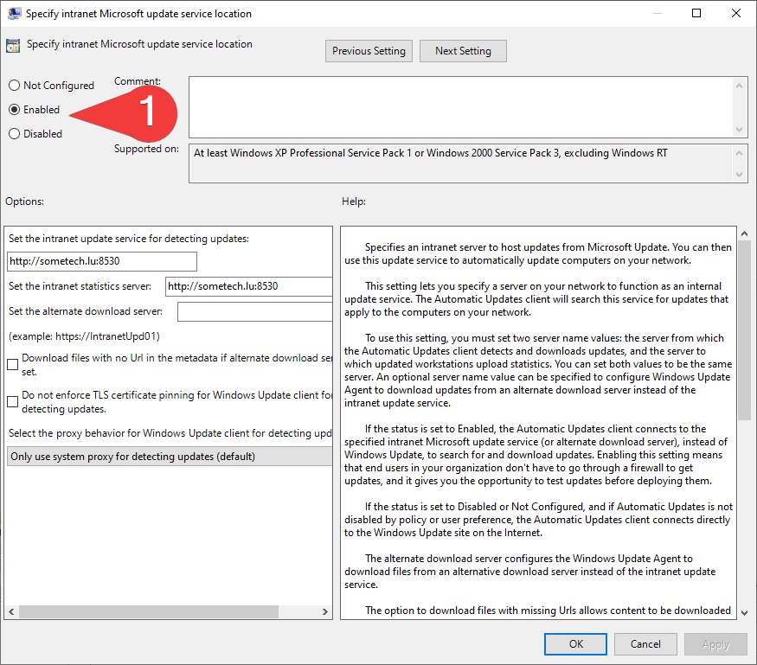
In the same location find the “Configure Automatic Updates” policy and open it. Enable the policy and configure it to your needs. In our case we want to install updates every day when no one is using the computer. It will download them but ask for confirmation before install. Therefore, we select option 3 (Auto download and notify for install).
Click on [OK]
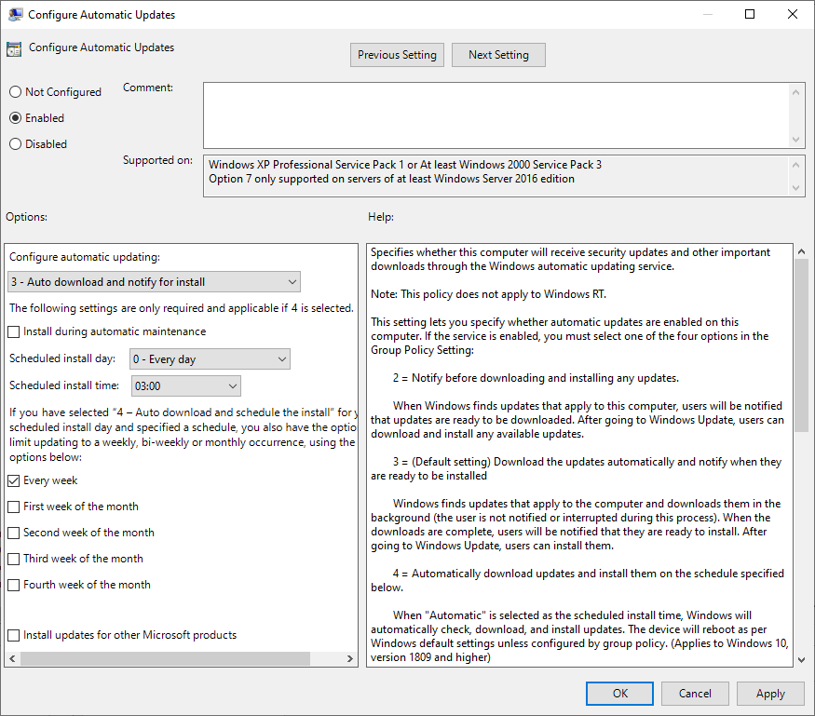
In the same location find the “Automatic Updates detection frequency” policy and open it. Enable the policy and configure it to your needs. In our case we will check for updates +- every 22 hours.
Click on [OK]
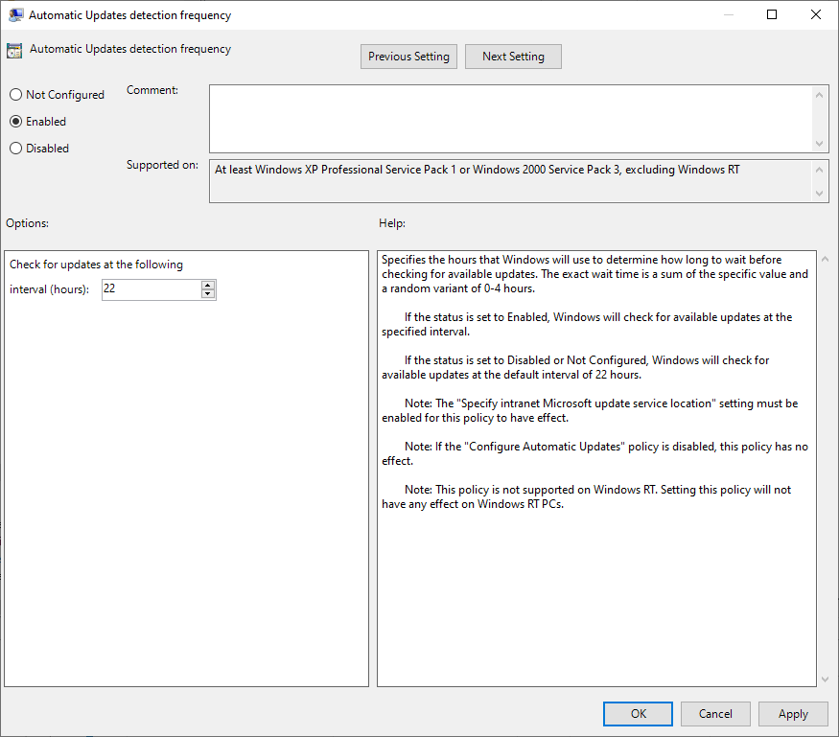
Here we link our GPOP to our Ous.
Once we have finished creating all our policies, we will link it to the organizational units. This can be done on the previous screen of the “Group Policy Management”. The students, reception and IT/testPC will get the new policy.
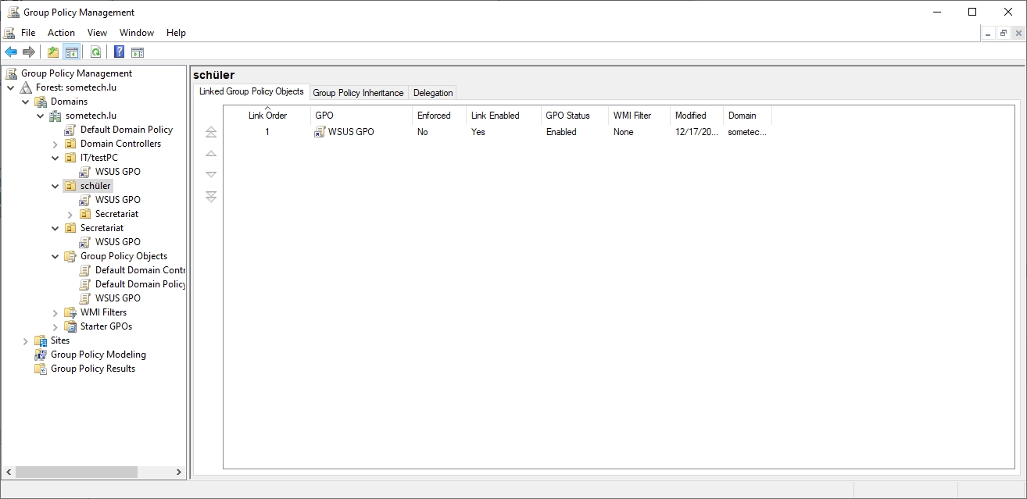
Now make sure the computer is in the Active Directory. Go to the system properties of the client and click on “Change” name. Make it a member of the domain.
Click on [OK]
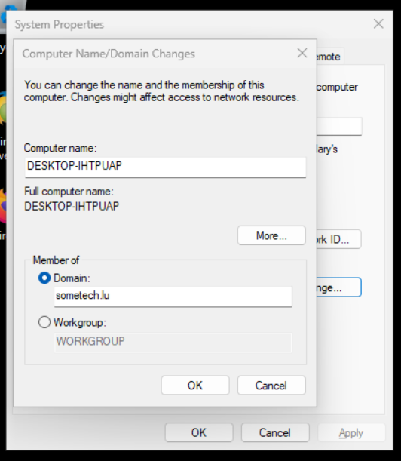

Now just authenticate with your AD Administrator credentials
Click on [OK]
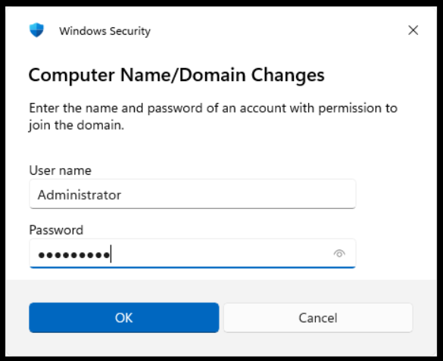
Your computer will now be a part of the AD. Now just put it in the correct OU.
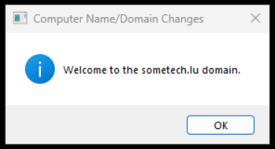

After putting it in the OU and restarting the PC, it should get the WSUS group policy. Here you can see that it applied the settings.
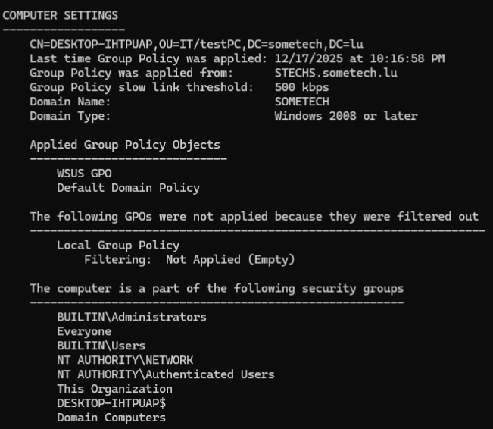
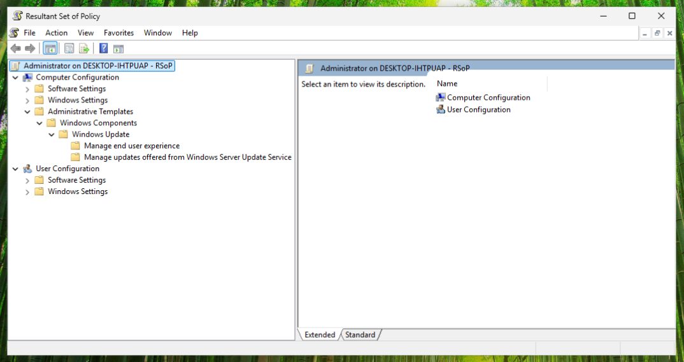

No table of figures entries found.

